Pizza sales SQL queries

1. KPI’S

TOTAL REVENUE

**select** **sum**(total_price) **as** *total_revenue*

**from** pizza.pizza_sales

AVERAGE ORDER VALUE

**select** **sum**(total_price)/ **count**(**distinct** order_id) **as** *avg_order_value*

**from** pizza.pizza_sales

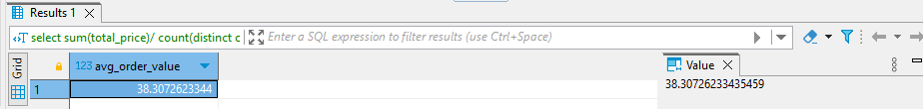

TOTAL PIZZA SOLD

**select** **sum**(quantity) **as** *total_pizza_sold*

**from** pizza.pizza_sales

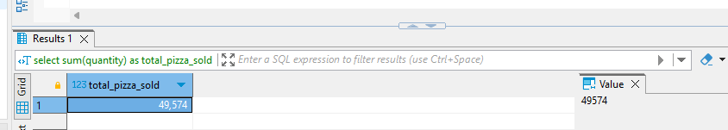

TOTAL ORDERS

**select** **count**(**distinct** order_id) **as** *total_orders*

**from** pizza.pizza_sales

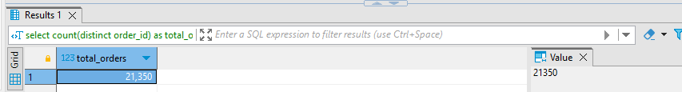

AVERAGE PIZZA PER ORDER

**select** **sum**(QUANTITY)/**count**(**distinct** ORDER_ID) **as** *pizza_per_order*

**from** pizza.pizza_sales

1. CHART REQUIREMENTS

DAILY TRENDS FOR TOTAL ORDERS

SELECT DATE_FORMAT(STR_TO_DATE(order_date, '%d-%m-%Y'), '%W') AS order_date,

COUNT(DISTINCT order_id) AS total_orders

FROM pizza.pizza_sales

GROUP BY DATE_FORMAT(STR_TO_DATE(order_date, '%d-%m-%Y'), '%W');

MONTHLY TRENDS FOR TOTAL ORDERS

**SELECT** **DATE_FORMAT**(STR_TO_DATE(order_date, **'%d-%m-%Y'**), **'%M'**) **AS** *month_date*,

**COUNT**(**DISTINCT** order_id) **AS** *total_orders*

**FROM** pizza.pizza_sales

**GROUP** **BY** **DATE_FORMAT**(STR_TO_DATE(order_date, **'%d-%m-%Y'**), **'%M'**)

**order** **by** *total_orders* **desc**;

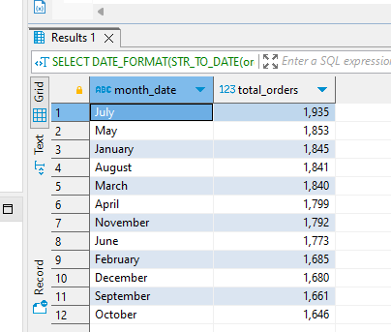

PERCENTAGE OF SALES BY PIZZA CATEGORY

**select** pizza_category, **round**(**sum**(total_price)*100 / (**select** **sum**(total_price)**from** pizza.pizza_sales),2) **as** *pct_total_sales*

**from** pizza.pizza_sales

**group** **by** pizza_category

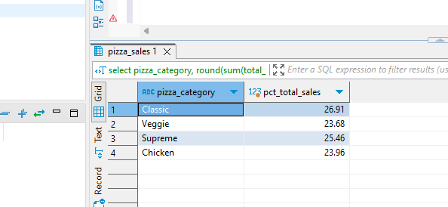

PERCENTAGE OF SALES BY PIZZA

**select** pizza_size, **round**(**sum**(total_price),2) **as** *total_sales*, **round**(**sum**(total_price) *100 / (**select** **sum**(total_price) **from** pizza.pizza_sales),2) **as** *pct_total_sales*

**from** pizza.pizza_sales

**group** **by** pizza_size

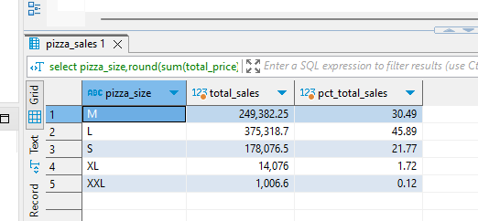

Top 5 Pizzas by Revenue

**select** pizza_name, **round**(**sum**(total_price),2) **as** *total_revenue*

**from** pizza.pizza_sales

**group** **by** pizza_name

**order** **by** *total_revenue* **desc**

**limit** 5

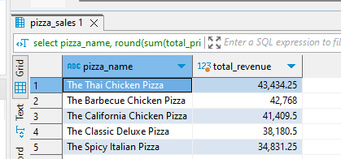

BOTTOM 5 PIZZA BY REVENUE

**select** pizza_name, **round**(**sum**(total_price),2) **as** *total_revenue*

**from** pizza.pizza_sales

**group** **by** pizza_name

**order** **by** *total_revenue*

**limit** 5

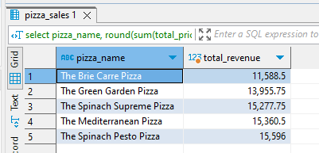

TOP 5 PIZZA BY QUANTITY

**select** pizza_name, **round**(**sum**(quantity),2) **as** *total_quantity*

**from** pizza.pizza_sales

**group** **by** pizza_name

**order** **by** *total_quantity* **desc**

**limit** 5

BOTTOM 5 PIZZA BY QUANTITY

**select** pizza_name, **round**(**sum**(quantity),2) **as** *total_quantity*

**from** pizza.pizza_sales

**group** **by** pizza_name

**order** **by** *total_quantity*

**limit** 5

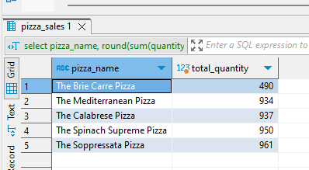

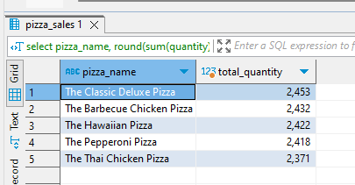TOP 5 PIZZA BY TOTAL ORDERS

**select** pizza_name, **count**(**distinct** order_id) **as** *total_orders*

**from** pizza.pizza_sales

**group** **by** pizza_name

**order** **by** *total_orders* **desc**

**limit** 5

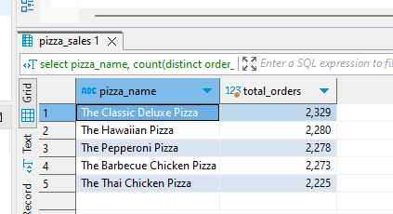

BOTTOM 5 PIZZA BY TOTAL ORDERS

**select** pizza_name, **count**(**distinct** order_id) **as** *total_orders*

**from** pizza.pizza_sales

**group** **by** pizza_name

**order** **by** *total_orders*

**limit** 5

